Chapter 4, Solution 31.

Determine v_{x} in the circuit of Fig. 4.99 using source transformation.

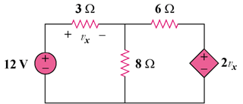

Figure 4.99
For Prob. 4.31.

Solution

Transform the dependent source so that we have the circuit in
Fig. (a). 6||8 = (24/7) ohms. Transform the dependent source again to get the circuit in Fig. (b).

(a)

3 Ω

6 Ω

v_{x}/3
+ −

v_{x}

12V

+
−

8 Ω

i

+

−

(b)

3 Ω

(8/7)v_{x}
+ −

v_{x}

12V

+
−

(24/7) Ω

From Fig. (b),

v_{x} = 3i, or i = v_{x}/3.

Applying KVL,

-12 + (3 + 24/7)i + (24/21)v_{x} = 0

12 = [(21 + 24)/7]v_{x}/3 + (8/7)v_{x}, leads to v_{x} = 84/23 = 3.652 V

